

**DEPARTMENT OF COMPUTER SCIENCE AND DESIGN**

**ACADEMIC YEAR 2024-2025 ODD SEMESTER**



**CD23332**

**LAB MANUAL**

**SECOND YEAR**

**THIRD SEMESTER**

**2024- 2025**

**ODD SEMESTER**

|  |  |  |
| --- | --- | --- |
| **List of Experiments** | | |
| 1 | Design to teach mathematics to the children of 4-5 years age in school in Rural sector | |
| 2 | Design to help people to sell their handmade products in metro cities | |
| 3 | Design a social media website and chat | |
| 4 | Design a publication that support different languages | |
| 5 | Design a publication that tells comic stories | |
| 6 | Design an advertisement for mobile company | |
| 7 | Design an advertisement for any political party with images | |
| 8 | Design an advertisement for electronic products | |
| 9 | Design an advertisement for food products | |
| 10 | Design an interactive website for new institution | |
| 11 | Design a blog that publish educational post | |
| 12 | Design an interactive website for hospital management system | |
| 13 | Design an interactive website for food selling app | |
| **Requirements** | | |
| Hardware | | Intel i3 or AMD processor with 64-bit support;2 GHz or faster processor with SSE 4. or later- 8 GB RAM -Windows 10 64-it (version 1909)or later - 1.5 GB of GPU memory -4 GB of available hard-disk space |
| Software | | Figma, Adobe Photoshop, HTML and CSS |
| Operating System | | Windows |

**LAB PLAN**

**CD23332-DESIGN PROCESSES AND PERSPECTIVES LAB**

|  |  |  |
| --- | --- | --- |
| **Exercise no.** | **Exercise Name** | **Required Hours** |
| 1 | Design to teach mathematics to the children of 4-5 years age in school in Rural sector | 3 |
| 2 | Design to help people to sell their handmade products in metro cities | 6 |
| 3 | Design a social media website and chat | 3 |
| 4 | Design a publication that support different languages | 3 |
| 5 | Design a publication that tells comic stories | 3 |
| 6 | Design an advertisement for mobile company | 3 |
| 7 | Design an advertisement for any political party with images | 9 |
| 8 | Design an advertisement for electronic products | 6 |
| 9 | Design an advertisement for food products | 6 |
| 10 | Design an interactive website for new institution | 6 |
| 11 | Design a blog that publish educational post | 6 |
| 12 | Design an interactive website for hospital management system. | 3 |
| 13 | Design an interactive website for food selling app. | 3 |

**Course Outcomes (COs)**

**Course Name: Design Processes and Perspectives Course Code: CD19341**

|  |  |
| --- | --- |
| Outcome 1 | Understand the various graphic design thinking process and phases |
| Outcome 2 | Analyze and choose between various visual components |
| Outcome 3 | Designing and communicating visual components |
| Outcome 4 | Apply design concepts for media publishing and advertising |
| Outcome 5 | Create website using different design concepts |

# CO-PO –PSO matricesofcourse

|  |  |  |  |  |  |  |  |  |  |  |  |  |  |  |  |
| --- | --- | --- | --- | --- | --- | --- | --- | --- | --- | --- | --- | --- | --- | --- | --- |
| PO/PSO  CO | PO 1 | PO 2 | PO 3 | PO 4 | PO 5 | PO 6 | PO 7 | PO 8 | PO 9 | PO 10 | PO 11 | PO 12 | PSO 1 | PSO 2 | PSO 3 |
| CD19341.1 | 3 | 1 | 3 | 2 | 3 | 2 | 3 | 2 | 1 | 1 | 1 | 3 | 1 | 3 | 1 |
| CD19341.2 | 3 | - | 3 | - | 3 | - | - | - | - | - | 1 | 1 | 1 | 3 | 1 |
| CD19341.3 | 3 | 3 | 3 | 2 | 3 | - | - | - | - | - | - | 1 | 1 | 3 | 2 |
| CD19341.4 | 1 | 3 | 3 | 3 | 3 | 3 | 2 | 2 | 2 | 2 | 2 | 2 | 1 | 3 | 3 |
| CD19341.5 | 1 | 3 | 3 | 3 | 3 | 3 | 2 | 2 | 2 | 2 | 2 | 2 | 1 | 3 | 3 |
| Average | 2.2 | 2.0 | 3.0 | 2.0 | 3.0 | 1.6 | 1.4 | 1.0 | 1.0 | 1.0 | 1.2 | 1.8 | 1.0 | 3.0 | 2.0 |

Note: Enter correlation levels 1,2 or 3 as defined below:

1: Slight(Low) 2: Moderate(Medium) 3: Substantial(High) If there is no correlation, put “-“

**Expt. No.:1**

**Date:**

**Design to teach mathematics to the children of 4-5 years age in school in Rural sector**

**Aim:** To design a user interface for teaching mathematics to the children of 4-5 years age in school in the rural sector.

**Tools:** Figma, Photoshop

**Steps:**

1. Create a new background layer.
2. Create containers for placing images, icons and logos.
3. Gradient color panel has to be used.
4. Buttons and attractive fonts have been used.
5. Proper navigation should be done to move from one page to another.
6. Login page has to be included.

**Output:**

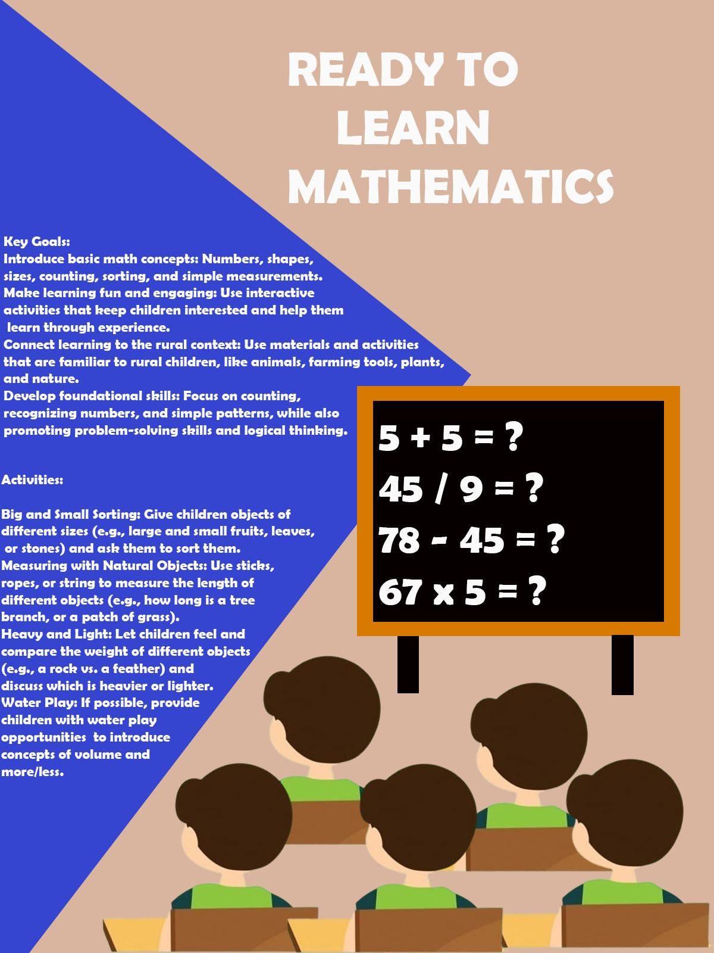

**Result:The Design is verified.**

**Expt. No.:2**

**Date:**

**Design to help people to sell their handmade products in metro cities**

**AIM:** To Design an UI that can help people to sell their handmade products in metro cities

**Tools:** Figma, Photoshop

**Steps:**

1. Create a new background layer.
2. Create containers for placing images, icons and logos.
3. Gradient color panel has to be used.
4. Buttons and attractive fonts have been used.
5. Proper navigation should be done to move from one page to another.
6. Login page has to be included.

**Output:**

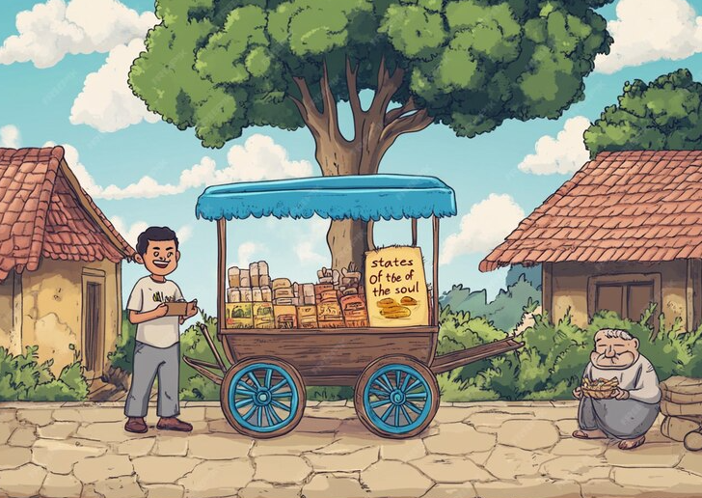

**Result:The Design is verified.**

**Expt. No.:3**

**Date:**

**Design a social media website and chat**

**Aim:** To design a user interface for teaching mathematics to the children of 4-5 years age in school in the rural sector.

**Tools:** Figma, Photoshop

**Steps:**

1. Create a new background layer.
2. Create containers for placing images, icons and logos
3. Gradient color panel has to be used
4. Buttons and attractive fonts have been used
5. Proper navigation should be done to move from one page to another
6. Login page has to be included

**Output:**



**Result:The Design is verified.**

**Expt. No.:4**

**Date:**

**Design a publication that support different languages**

**Aim:** To design a publication that support different language

**Tools:** Adobe Photoshop

**Steps:**

1. Create a new background layer.
2. Create containers for placing images, icons and logos
3. Gradient color panel has to be used
4. Use different languages to display the content.
5. Use images that support the content.
6. Align white spaces between the contents.

**Output:**



**Result:The Design is verified.**

**Expt. No.:5**

**Date:**

**Design a publication that tells comic storiess**

**Aim:** To design a Publication That Tells Comic Stories

**Tools:**  Adobe Photoshop

**Steps:**

1. Create a new background layer.

2. Create containers for placing images, icons and logos

3. Gradient color panel has to be used.

4. Use different languages to display the content.

5. Use images that support the content.

6. Align white spaces between the contents.

**Output:**

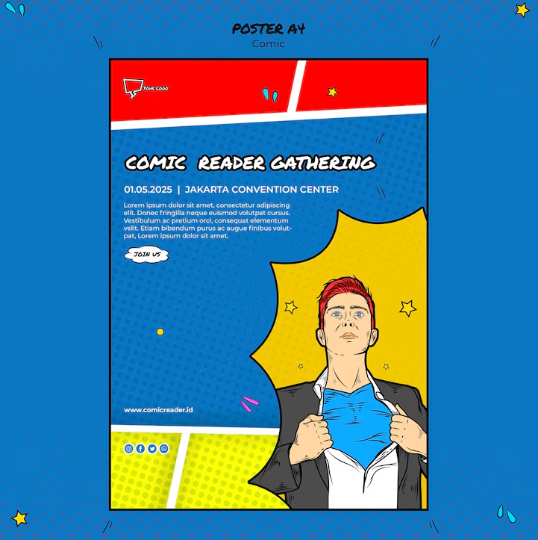

**Result:The Design is verified.**

**Expt. No.:6**

**Date:**

**Design an advertisement for mobile company**

**Aim:** To design an advertisement for mobile company

**Tools:**  Adobe Photoshop, Canva

**Steps:**

1. Create a new background layer.

2. Create containers for placing images, icons and logos

3. Gradient color panel has to be used

4. Images that support the context must be placed.

5. Written context must be emphasized.

6. Appropriate color palette must be used.

**Output:**

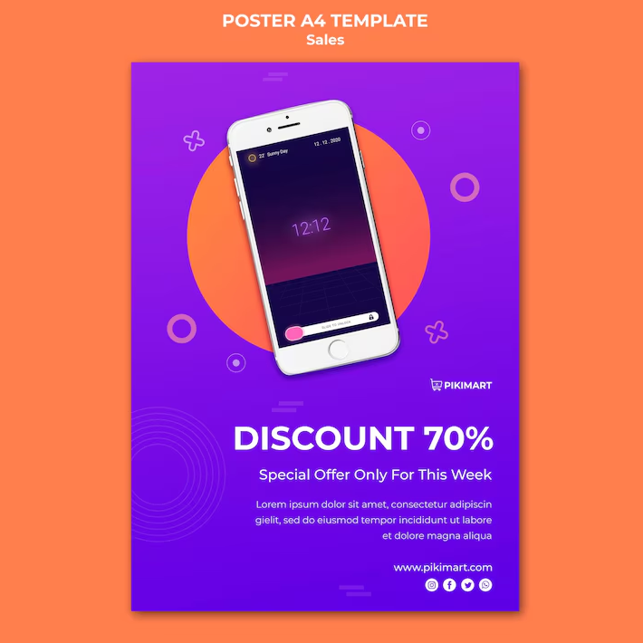

**Result:The Design is verified.**

**Expt. No.:7**

**Date:**

**Design an advertisement for any political party with images**

**Aim:** To design an advertisement for any political party with images

**Tools:**  Adobe Photoshop, Canva.

**Steps:**

1. Create a new background layer.

2. Create containers for placing images, icons and logos.

3. Gradient color panel has to be used.

4. Images that support the context must be placed.

5. Written context must be emphasized.

6. Appropriate color palette must be used.

**Output:**



**Result:The Design is verified.**

**Expt. No.:8**

**Date:**

**Design an advertisement for electronic products**

**Aim:** To design an advertisement for electronic products

**Tools:**  Adobe Photoshop, Canva

**Steps:**

1. Create a new background layer.

2. Create containers for placing images, icons and logos.

3. Gradient color panel has to be used .

4. Images that support the context must be placed.

5. Written context must be emphasized.

6. Appropriate color palette must be used.

**Output:**

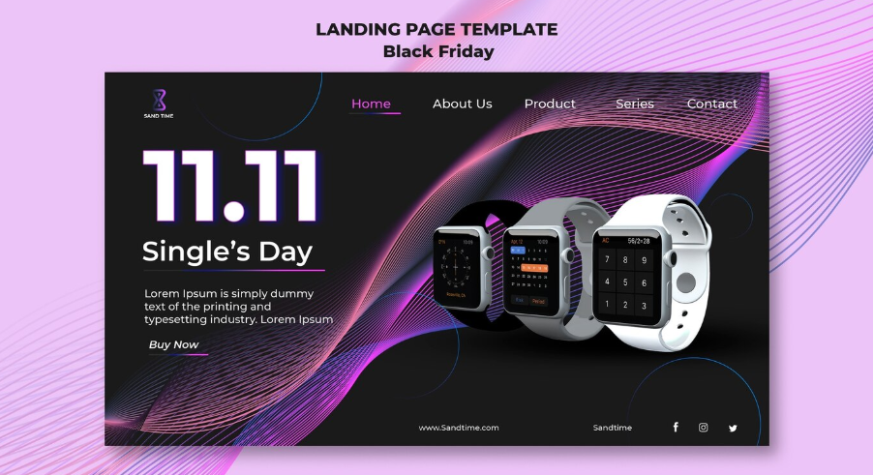

**Result:The Design is verified.**

**Expt. No.:9**

**Date:**

**Design an advertisement for food products**

**Aim:** To design an advertisement for food products

**Tools:**  Adobe Photoshop, Canva

**Steps:**

1. Create a new background layer.

2. Create containers for placing images, icons and logos.

3. Gradient color panel has to be used .

4. Images that support the context must be placed.

5. Written context must be emphasized.

6. Appropriate color palette must be used.

**Output:**

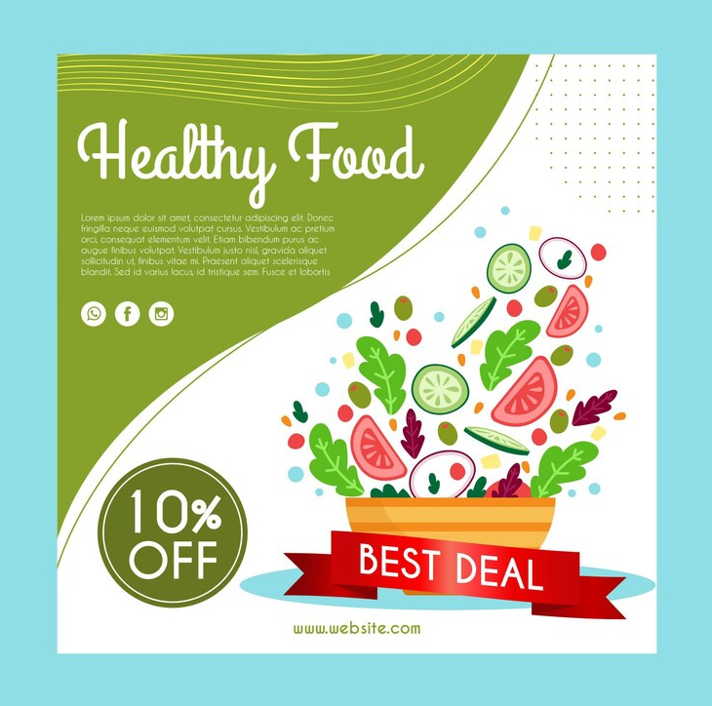

**Result:The Design is verified.**

**Expt. No.:10**

**Date:**

**Design an interactive website for new institution**

**Aim:** To design interactive website for new institution

**Tools:** HTML, CSS

**Steps:**

1. Create a document of type HTML.

2. Craft a style sheet for better design.

3. Include the link of the stylesheet to the HTML file.

4. Assign a title for each page.

5. Add the required styles and attributes for the HTML tags.

6. Include action tag to navigate from one page to another.

**Output:**

**HTML:**

**<!DOCTYPE html>**

**<html lang="en">**

**<head>**

**<meta charset="UTF-8">**

**<meta name="viewport" content="width=device-width, initial-scale=1.0">**

**<meta http-equiv="X-UA-Compatible" content="ie=edge">**

**<title>Welcome to Our Institution</title>**

**<link rel="stylesheet" href="styles.css">**

**</head>**

**<body>**

**<!-- Header Section -->**

**<header>**

**<nav>**

**<div class="logo">**

**<h1>Our Institution</h1>**

**</div>**

**<ul>**

**<li><a href="#home">Home</a></li>**

**<li><a href="#about">About Us</a></li>**

**<li><a href="#programs">Programs</a></li>**

**<li><a href="#contact">Contact Us</a></li>**

**</ul>**

**</nav>**

**</header>**

**<!-- Hero Section -->**

**<section id="home" class="hero">**

**<div class="hero-content">**

**<h2>Welcome to Our New Institution</h2>**

**<p>Where education meets excellence and opportunity.</p>**

**<a href="#contact" class="cta-button">Contact Us</a>**

**</div>**

**</section>**

**<!-- About Us Section -->**

**<section id="about" class="about">**

**<h2>About Us</h2>**

**<p>We are a new institution dedicated to providing world-class education to students in all fields. Our mission is to nurture the minds of tomorrow and prepare them for the challenges ahead.</p>**

**</section>**

**<!-- Programs Section -->**

**<section id="programs" class="programs">**

**<h2>Our Programs</h2>**

**<div class="program-list">**

**<div class="program-card">**

**<h3>Undergraduate Programs</h3>**

**<p>Explore a wide range of undergraduate degrees designed to give you a solid foundation in your field.</p>**

**</div>**

**<div class="program-card">**

**<h3>Postgraduate Programs</h3>**

**<p>Advanced study programs to deepen your knowledge and enhance your career prospects.</p>**

**</div>**

**<div class="program-card">**

**<h3>Online Courses</h3>**

**<p>Flexible learning options for working professionals and those looking to expand their skills.</p>**

**</div>**

**</div>**

**</section>**

**<!-- Contact Us Section -->**

**<section id="contact" class="contact">**

**<h2>Contact Us</h2>**

**<p>Have any questions? Get in touch with us!</p>**

**<form action="#">**

**<input type="text" placeholder="Your Name" required>**

**<input type="email" placeholder="Your Email" required>**

**<textarea placeholder="Your Message" required></textarea>**

**<button type="submit">Send Message</button>**

**</form>**

**</section>**

**<!-- Footer Section -->**

**<footer>**

**<div class="footer-content">**

**<p>&copy; 2024 Our Institution. All rights reserved.</p>**

**<div class="social-links">**

**<a href="#" target="_blank">Facebook</a>**

**<a href="#" target="_blank">Twitter</a>**

**<a href="#" target="_blank">Instagram</a>**

**</div>**

**</div>**

**</footer>**

**</body>**

**</html>**

**CSS:**

**/* General Reset */**

**\* {**

**margin: 0;**

**padding: 0;**

**box-sizing: border-box;**

**}**

**/* Body and Font */**

**body {**

**font-family: Arial, sans-serif;**

**line-height: 1.6;**

**background-color: #f4f4f4;**

**color: #333;**

**}**

**/* Header Styles */**

**header {**

**background-color: #333;**

**color: #fff;**

**padding: 1rem 0;**

**}**

**nav {**

**display: flex;**

**justify-content: space-between;**

**align-items: center;**

**padding: 0 2rem;**

**}**

**nav .logo h1 {**

**font-size: 2rem;**

**}**

**nav ul {**

**list-style-type: none;**

**display: flex;**

**}**

**nav ul li {**

**margin: 0 1rem;**

**}**

**nav ul li a {**

**color: #fff;**

**text-decoration: none;**

**font-size: 1.2rem;**

**transition: color 0.3s ease;**

**}**

**nav ul li a:hover {**

**color: #f0a500;**

**}**

**/* Hero Section */**

**.hero {**

**background: url('hero-image.jpg') no-repeat center center/cover;**

**height: 500px;**

**display: flex;**

**justify-content: center;**

**align-items: center;**

**color: white;**

**text-align: center;**

**}**

**.hero-content h2 {**

**font-size: 3rem;**

**margin-bottom: 20px;**

**}**

**.hero-content p {**

**font-size: 1.5rem;**

**margin-bottom: 30px;**

**}**

**.cta-button {**

**background-color: #f0a500;**

**color: white;**

**padding: 10px 20px;**

**text-decoration: none;**

**font-size: 1.2rem;**

**border-radius: 5px;**

**transition: background-color 0.3s;**

**}**

**.cta-button:hover {**

**background-color: #e89e00;**

**}**

**/* About Section */**

**.about {**

**padding: 2rem;**

**text-align: center;**

**background-color: #fff;**

**}**

**.about h2 {**

**font-size: 2.5rem;**

**margin-bottom: 20px;**

**}**

**.about p {**

**font-size: 1.2rem;**

**color: #555;**

**max-width: 800px;**

**margin: 0 auto;**

**}**

**/* Programs Section */**

**.programs {**

**padding: 2rem;**

**background-color: #f8f8f8;**

**text-align: center;**

**}**

**.programs h2 {**

**font-size: 2.5rem;**

**margin-bottom: 40px;**

**}**

**.program-list {**

**display: flex;**

**justify-content: space-around;**

**flex-wrap: wrap;**

**}**

**.program-card {**

**background-color: #fff;**

**padding: 20px;**

**border-radius: 10px;**

**width: 30%;**

**margin: 10px;**

**box-shadow: 0 4px 8px rgba(0, 0, 0, 0.1);**

**transition: transform 0.3s ease;**

**}**

**.program-card:hover {**

**transform: translateY(-10px);**

**}**

**.program-card h3 {**

**font-size: 1.8rem;**

**margin-bottom: 10px;**

**}**

**.program-card p {**

**font-size: 1rem;**

**color: #555;**

**}**

**/* Contact Section */**

**.contact {**

**padding: 2rem;**

**background-color: #fff;**

**text-align: center;**

**}**

**.contact h2 {**

**font-size: 2.5rem;**

**margin-bottom: 20px;**

**}**

**.contact p {**

**font-size: 1.2rem;**

**margin-bottom: 30px;**

**}**

**form {**

**display: flex;**

**flex-direction: column;**

**align-items: center;**

**max-width: 500px;**

**margin: 0 auto;**

**}**

**form input, form textarea {**

**width: 80%;**

**padding: 10px;**

**margin-bottom: 20px;**

**border: 2px solid #ccc;**

**border-radius: 5px;**

**font-size: 1rem;**

**}**

**form button {**

**padding: 10px 20px;**

**background-color: #f0a500;**

**color: white;**

**border: none;**

**border-radius: 5px;**

**font-size: 1.2rem;**

**cursor: pointer;**

**transition: background-color 0.3s ease;**

**}**

**form button:hover {**

**background-color: #e89e00;**

**}**

**/* Footer Section */**

**footer {**

**background-color: #333;**

**color: #fff;**

**padding: 20px 0;**

**text-align: center;**

**}**

**footer p {**

**font-size: 1rem;**

**}**

**.social-links a {**

**color: #fff;**

**text-decoration: none;**

**margin: 0 15px;**

**font-size: 1.2rem;**

**transition: color 0.3s;**

**}**

**.social-links a:hover {**

**color: #f0a500;**

**}**

**Result:The HTML and CSS code is verified.**

**Expt. No.:11**

**Date:**

**Design A Blog That Publish Educational Post**

**Aim:** To design a blog that publishes educational post

**Tools:** HTML, CSS

**Steps:**

1. Create a document of type HTML.

2. Craft a style sheet for better design.

3. Include the link of the stylesheet to the HTML file.

4. Assign a title for each page.

5. Add the required styles and attributes for the HTML tags.

6. Include action tag to navigate from one page to another.

**Output:**

**HTML:**

**<!DOCTYPE html>**

**<html lang="en">**

**<head>**

**<meta charset="UTF-8">**

**<meta name="viewport" content="width=device-width, initial-scale=1.0">**

**<meta http-equiv="X-UA-Compatible" content="ie=edge">**

**<title>Educational Blog</title>**

**<link rel="stylesheet" href="styles.css">**

**</head>**

**<body>**

**<!-- Header Section -->**

**<header>**

**<nav>**

**<div class="logo">**

**<h1>EduBlog</h1>**

**</div>**

**<ul>**

**<li><a href="#">Home</a></li>**

**<li><a href="#about">About</a></li>**

**<li><a href="#categories">Categories</a></li>**

**<li><a href="#contact">Contact</a></li>**

**</ul>**

**</nav>**

**</header>**

**<!-- Main Blog Feed Section -->**

**<section class="main-blog-feed">**

**<div class="container">**

**<div class="main-posts">**

**<article class="post">**

**<h2><a href="#">5 Ways to Improve Your Study Habits</a></h2>**

**<p class="meta">Posted on March 20, 2024 by <a href="#">John Doe</a></p>**

**<img src="study-habits.jpg" alt="Study Habits">**

**<p>Learning efficiently can be challenging. But with a few simple strategies, you can improve your study habits and boost your grades...</p>**

**<a href="#" class="read-more">Read More</a>**

**</article>**

**<article class="post">**

**<h2><a href="#">The Importance of Early Childhood Education</a></h2>**

**<p class="meta">Posted on March 18, 2024 by <a href="#">Jane Smith</a></p>**

**<img src="child-education.jpg" alt="Early Childhood Education">**

**<p>Early childhood education has been proven to have long-term positive effects. This post explores why it’s crucial for children’s development...</p>**

**<a href="#" class="read-more">Read More</a>**

**</article>**

**<!-- Add more posts as needed -->**

**</div>**

**<!-- Sidebar Section -->**

**<div class="sidebar">**

**<section class="search">**

**<input type="text" placeholder="Search posts...">**

**</section>**

**<section class="recent-posts">**

**<h3>Recent Posts</h3>**

**<ul>**

**<li><a href="#">How to Stay Motivated in Online Classes</a></li>**

**<li><a href="#">10 Best Online Learning Resources for Students</a></li>**

**<li><a href="#">How to Overcome Procrastination</a></li>**

**</ul>**

**</section>**

**<section class="categories">**

**<h3>Categories</h3>**

**<ul>**

**<li><a href="#">Study Tips</a></li>**

**<li><a href="#">Online Learning</a></li>**

**<li><a href="#">Student Well-being</a></li>**

**</ul>**

**</section>**

**</div>**

**</div>**

**</section>**

**<!-- Footer Section -->**

**<footer>**

**<div class="footer-content">**

**<p>&copy; 2024 EduBlog. All rights reserved.</p>**

**<div class="social-links">**

**<a href="#" target="_blank">Facebook</a>**

**<a href="#" target="_blank">Twitter</a>**

**<a href="#" target="_blank">Instagram</a>**

**</div>**

**</div>**

**</footer>**

**</body>**

**</html>**

**CSS:**

**/* General Reset */**

**\* {**

**margin: 0;**

**padding: 0;**

**box-sizing: border-box;**

**}**

**/* Body and Font */**

**body {**

**font-family: 'Arial', sans-serif;**

**line-height: 1.6;**

**background-color: #f4f4f4;**

**color: #333;**

**}**

**/* Header Styles */**

**header {**

**background-color: #333;**

**color: #fff;**

**padding: 1rem 0;**

**}**

**nav {**

**display: flex;**

**justify-content: space-between;**

**align-items: center;**

**padding: 0 2rem;**

**}**

**nav .logo h1 {**

**font-size: 2rem;**

**}**

**nav ul {**

**list-style-type: none;**

**display: flex;**

**}**

**nav ul li {**

**margin: 0 1rem;**

**}**

**nav ul li a {**

**color: #fff;**

**text-decoration: none;**

**font-size: 1.2rem;**

**transition: color 0.3s ease;**

**}**

**nav ul li a:hover {**

**color: #f0a500;**

**}**

**/* Main Blog Feed */**

**.main-blog-feed {**

**padding: 3rem 0;**

**background-color: #fff;**

**}**

**.container {**

**display: flex;**

**justify-content: space-between;**

**margin: 0 2rem;**

**}**

**.main-posts {**

**flex: 0 0 70%;**

**}**

**.post {**

**margin-bottom: 2rem;**

**padding: 2rem;**

**border-bottom: 1px solid #ccc;**

**}**

**.post h2 {**

**font-size: 2rem;**

**margin-bottom: 1rem;**

**}**

**.post .meta {**

**font-size: 1rem;**

**color: #555;**

**}**

**.post img {**

**max-width: 100%;**

**height: auto;**

**margin: 1rem 0;**

**}**

**.read-more {**

**display: inline-block;**

**margin-top: 1rem;**

**padding: 10px 20px;**

**background-color: #f0a500;**

**color: white;**

**text-decoration: none;**

**border-radius: 5px;**

**transition: background-color 0.3s ease;**

**}**

**.read-more:hover {**

**background-color: #e89e00;**

**}**

**/* Sidebar */**

**.sidebar {**

**flex: 0 0 25%;**

**padding: 2rem;**

**background-color: #f9f9f9;**

**border-radius: 8px;**

**box-shadow: 0 2px 5px rgba(0, 0, 0, 0.1);**

**}**

**.search input {**

**width: 100%;**

**padding: 10px;**

**margin-bottom: 1.5rem;**

**border: 2px solid #ccc;**

**border-radius: 5px;**

**}**

**.recent-posts, .categories {**

**margin-bottom: 2rem;**

**}**

**.recent-posts ul, .categories ul {**

**list-style-type: none;**

**}**

**.recent-posts li, .categories li {**

**margin-bottom: 10px;**

**}**

**.recent-posts a, .categories a {**

**color: #333;**

**text-decoration: none;**

**font-size: 1rem;**

**}**

**.recent-posts a:hover, .categories a:hover {**

**color: #f0a500;**

**}**

**/* Footer */**

**footer {**

**background-color: #333;**

**color: #fff;**

**padding: 1rem 0;**

**text-align: center;**

**}**

**footer .social-links {**

**margin-top: 1rem;**

**}**

**footer .social-links a {**

**color: #fff;**

**text-decoration: none;**

**margin: 0 10px;**

**font-size: 1.2rem;**

**transition: color 0.3s ease;**

**}**

**footer .social-links a:hover {**

**color: #f0a500;**

**}**

**Result:The HTML and CSS code is verified.**

**Expt. No.:12**

**Date:**

**Design An Interactive Website For Hospital Management System**

**Aim:** To design interactive website for hospital management system

**Tools:** HTML, CSS

**Steps:**

1. Create a document of type HTML.

2. Craft a style sheet for better design.

3. Include the link of the stylesheet to the HTML file.

4. Assign a title for each page.

5. Add the required styles and attributes for the HTML tags.

6. Include action tag to navigate from one page to another.

**Output:**

**HTML:**

**<!DOCTYPE html>**

**<html lang="en">**

**<head>**

**<meta charset="UTF-8">**

**<meta name="viewport" content="width=device-width, initial-scale=1.0">**

**<meta http-equiv="X-UA-Compatible" content="ie=edge">**

**<title>Hospital Management System</title>**

**<link rel="stylesheet" href="styles.css">**

**</head>**

**<body>**

**<!-- Header Section -->**

**<header>**

**<nav>**

**<div class="logo">**

**<h1>HospitalCare</h1>**

**</div>**

**<ul>**

**<li><a href="#home">Home</a></li>**

**<li><a href="#services">Services</a></li>**

**<li><a href="#appointments">Appointments</a></li>**

**<li><a href="#contact">Contact</a></li>**

**<li><a href="#login">Login</a></li>**

**</ul>**

**</nav>**

**</header>**

**<!-- Hero Section -->**

**<section id="home" class="hero">**

**<div class="hero-content">**

**<h2>Welcome to HospitalCare</h2>**

**<p>Your health, our priority. Providing expert care and modern treatment.</p>**

**<a href="#appointments" class="cta-button">Book an Appointment</a>**

**</div>**

**</section>**

**<!-- Services Section -->**

**<section id="services" class="services">**

**<h2>Our Services</h2>**

**<div class="service-list">**

**<div class="service-card">**

**<h3>General Consultation</h3>**

**<p>Experienced doctors available for general health checkups.</p>**

**</div>**

**<div class="service-card">**

**<h3>Emergency Care</h3>**

**<p>24/7 emergency services with well-equipped facilities.</p>**

**</div>**

**<div class="service-card">**

**<h3>Specialized Treatments</h3>**

**<p>Expert care in cardiology, neurology, and more.</p>**

**</div>**

**</div>**

**</section>**

**<!-- Appointment Booking Section -->**

**<section id="appointments" class="appointments">**

**<h2>Book an Appointment</h2>**

**<form action="#">**

**<input type="text" placeholder="Your Name" required>**

**<input type="email" placeholder="Your Email" required>**

**<input type="text" placeholder="Preferred Doctor" required>**

**<input type="date" placeholder="Preferred Date" required>**

**<button type="submit">Book Appointment</button>**

**</form>**

**</section>**

**<!-- Login Section -->**

**<section id="login" class="login">**

**<h2>Login</h2>**

**<div class="login-form">**

**<button class="login-btn">Patient Login</button>**

**<button class="login-btn">Doctor Login</button>**

**</div>**

**</section>**

**<!-- Footer Section -->**

**<footer>**

**<div class="footer-content">**

**<p>&copy; 2024 HospitalCare. All rights reserved.</p>**

**<div class="social-links">**

**<a href="#">Facebook</a>**

**<a href="#">Twitter</a>**

**<a href="#">Instagram</a>**

**</div>**

**</div>**

**</footer>**

**</body>**

**</html>**

**CSS:**

**/* General Reset */**

**\* {**

**margin: 0;**

**padding: 0;**

**box-sizing: border-box;**

**}**

**/* Body and Font */**

**body {**

**font-family: 'Arial', sans-serif;**

**line-height: 1.6;**

**background-color: #f4f4f4;**

**color: #333;**

**}**

**/* Header Styles */**

**header {**

**background-color: #2c3e50;**

**color: #fff;**

**padding: 1rem 0;**

**}**

**nav {**

**display: flex;**

**justify-content: space-between;**

**align-items: center;**

**padding: 0 2rem;**

**}**

**nav .logo h1 {**

**font-size: 2rem;**

**}**

**nav ul {**

**list-style-type: none;**

**display: flex;**

**}**

**nav ul li {**

**margin: 0 1rem;**

**}**

**nav ul li a {**

**color: #fff;**

**text-decoration: none;**

**font-size: 1.2rem;**

**transition: color 0.3s ease;**

**}**

**nav ul li a:hover {**

**color: #f0a500;**

**}**

**/* Hero Section */**

**.hero {**

**background: url('hospital-hero.jpg') no-repeat center center/cover;**

**height: 500px;**

**display: flex;**

**justify-content: center;**

**align-items: center;**

**color: white;**

**text-align: center;**

**}**

**.hero-content h2 {**

**font-size: 3rem;**

**margin-bottom: 20px;**

**}**

**.hero-content p {**

**font-size: 1.5rem;**

**margin-bottom: 30px;**

**}**

**.cta-button {**

**background-color: #f0a500;**

**color: white;**

**padding: 10px 20px;**

**text-decoration: none;**

**font-size: 1.2rem;**

**border-radius: 5px;**

**transition: background-color 0.3s;**

**}**

**.cta-button:hover {**

**background-color: #e89e00;**

**}**

**/* Services Section */**

**.services {**

**padding: 2rem;**

**text-align: center;**

**background-color: #fff;**

**}**

**.services h2 {**

**font-size: 2.5rem;**

**margin-bottom: 20px;**

**}**

**.service-list {**

**display: flex;**

**justify-content: space-around;**

**flex-wrap: wrap;**

**}**

**.service-card {**

**background-color: #fff;**

**padding: 20px;**

**border-radius: 10px;**

**width: 30%;**

**margin: 10px;**

**box-shadow: 0 4px 8px rgba(0, 0, 0, 0.1);**

**}**

**.service-card h3 {**

**font-size: 1.8rem;**

**margin-bottom: 10px;**

**}**

**.service-card p {**

**font-size: 1rem;**

**color: #555;**

**}**

**/* Appointments Section */**

**.appointments {**

**padding: 2rem;**

**background-color: #f8f8f8;**

**text-align: center;**

**}**

**.appointments h2 {**

**font-size: 2.5rem;**

**margin-bottom: 20px;**

**}**

**.appointments form {**

**display: flex;**

**flex-direction: column;**

**align-items: center;**

**max-width: 500px;**

**margin: 0 auto;**

**}**

**.appointments input {**

**width: 80%;**

**padding: 10px;**

**margin-bottom: 20px;**

**border: 2px solid #ccc;**

**border-radius: 5px;**

**font-size: 1rem;**

**}**

**.appointments button {**

**padding: 10px 20px;**

**background-color: #f0a500;**

**color: white;**

**border: none;**

**border-radius: 5px;**

**font-size: 1.2rem;**

**cursor: pointer;**

**transition: background-color 0.3s ease;**

**}**

**.appointments button:hover {**

**background-color: #e89e00;**

**}**

**/* Login Section */**

**.login {**

**padding: 2rem;**

**background-color: #fff;**

**text-align: center;**

**}**

**.login h2 {**

**font-size: 2.5rem;**

**margin-bottom: 20px;**

**}**

**.login .login-form button {**

**padding: 10px 20px;**

**background-color: #3498db;**

**color: white;**

**border: none;**

**border-radius: 5px;**

**font-size: 1.2rem;**

**margin: 10px;**

**cursor: pointer;**

**transition: background-color 0.3s ease;**

**}**

**.login .login-form button:hover {**

**background-color: #2980b9;**

**}**

**/* Footer Section */**

**footer {**

**background-color: #2c3e50;**

**color: #fff;**

**padding: 1rem 0;**

**text-align: center;**

**}**

**footer p {**

**font-size: 1rem;**

**}**

**footer .social-links a {**

**color**

**Result: The HTML and CSS code is verified.**

**Expt. No.:13**

**Date:**

**Design An Interactive Website For Food Selling App**

**Aim:** To design a interactive website for food selling app

**Tools:** HTML, CSS

**Steps:**

1. Create a document of type HTML.

2. Craft a style sheet for better design.

3. Include the link of the stylesheet to the HTML file.

4. Assign a title for each page.

5. Add the required styles and attributes for the HTML tags.

6. Include action tag to navigate from one page to another.

**Output:**

**HTML:**

**<!DOCTYPE html>**

**<html lang="en">**

**<head>**

**<meta charset="UTF-8">**

**<meta name="viewport" content="width=device-width, initial-scale=1.0">**

**<meta http-equiv="X-UA-Compatible" content="ie=edge">**

**<title>Foodie - Online Food Ordering</title>**

**<link rel="stylesheet" href="styles.css">**

**</head>**

**<body>**

**<!-- Header Section -->**

**<header>**

**<nav>**

**<div class="logo">**

**<h1>Foodie</h1>**

**</div>**

**<ul>**

**<li><a href="#home">Home</a></li>**

**<li><a href="#menu">Menu</a></li>**

**<li><a href="#about">About</a></li>**

**<li><a href="#contact">Contact</a></li>**

**<li><a href="#login">Login</a></li>**

**</ul>**

**</nav>**

**</header>**

**<!-- Hero Section -->**

**<section id="home" class="hero">**

**<div class="hero-content">**

**<h2>Welcome to Foodie</h2>**

**<p>Delicious meals delivered to your doorsteps.</p>**

**<a href="#menu" class="cta-button">Order Now</a>**

**</div>**

**</section>**

**<!-- Featured Dishes Section -->**

**<section id="featured" class="featured">**

**<h2>Featured Dishes</h2>**

**<div class="dish-list">**

**<div class="dish-card">**

**<img src="burger.jpg" alt="Burger">**

**<h3>Cheese Burger</h3>**

**<p>Delicious beef patty with cheddar cheese, lettuce, and sauce.</p>**

**<p><strong>$10.99</strong></p>**

**<button>Add to Cart</button>**

**</div>**

**<div class="dish-card">**

**<img src="pizza.jpg" alt="Pizza">**

**<h3>Margherita Pizza</h3>**

**<p>Classic pizza with fresh tomatoes, mozzarella, and basil.</p>**

**<p><strong>$12.99</strong></p>**

**<button>Add to Cart</button>**

**</div>**

**<div class="dish-card">**

**<img src="pasta.jpg" alt="Pasta">**

**<h3>Spaghetti Carbonara</h3>**

**<p>Creamy pasta with bacon, eggs, and parmesan.</p>**

**<p><strong>$11.99</strong></p>**

**<button>Add to Cart</button>**

**</div>**

**</div>**

**</section>**

**<!-- Menu Section -->**

**<section id="menu" class="menu">**

**<h2>Our Menu</h2>**

**<div class="menu-list">**

**<div class="menu-category">**

**<h3>Burgers</h3>**

**<ul>**

**<li>Cheese Burger - $10.99</li>**

**<li>Bacon Burger - $12.99</li>**

**<li>Veggie Burger - $9.99</li>**

**</ul>**

**</div>**

**<div class="menu-category">**

**<h3>Pizzas</h3>**

**<ul>**

**<li>Margherita - $12.99</li>**

**<li>Pepperoni - $13.99</li>**

**<li>BBQ Chicken - $14.99</li>**

**</ul>**

**</div>**

**<div class="menu-category">**

**<h3>Pasta</h3>**

**<ul>**

**<li>Spaghetti Carbonara - $11.99</li>**

**<li>Penne Arrabbiata - $12.99</li>**

**<li>Mac & Cheese - $10.99</li>**

**</ul>**

**</div>**

**</div>**

**</section>**

**<!-- Contact Section -->**

**<section id="contact" class="contact">**

**<h2>Contact Us</h2>**

**<p>Have a question or want to provide feedback? Get in touch!</p>**

**<p><strong>Email:</strong> contact@foodie.com</p>**

**<p><strong>Phone:</strong> +1 800 123 4567</p>**

**<p><strong>Address:</strong> 123 Foodie Lane, Food City</p>**

**</section>**

**<!-- Login Section -->**

**<section id="login" class="login">**

**<h2>Login</h2>**

**<button class="login-btn">Customer Login</button>**

**<button class="login-btn">Restaurant Owner Login</button>**

**</section>**

**<!-- Footer Section -->**

**<footer>**

**<div class="footer-content">**

**<p>&copy; 2024 Foodie. All rights reserved.</p>**

**<div class="social-links">**

**<a href="#">Facebook</a>**

**<a href="#">Twitter</a>**

**<a href="#">Instagram</a>**

**</div>**

**</div>**

**</footer>**

**</body>**

**</html>**

**CSS:**

**/* General Reset */**

**\* {**

**margin: 0;**

**padding: 0;**

**box-sizing: border-box;**

**}**

**/* Body and Font */**

**body {**

**font-family: 'Arial', sans-serif;**

**line-height: 1.6;**

**background-color: #f4f4f4;**

**color: #333;**

**}**

**/* Header Section */**

**header {**

**background-color: #2c3e50;**

**color: #fff;**

**padding: 1rem 0;**

**}**

**nav {**

**display: flex;**

**justify-content: space-between;**

**align-items: center;**

**padding: 0 2rem;**

**}**

**nav .logo h1 {**

**font-size: 2rem;**

**}**

**nav ul {**

**list-style-type: none;**

**display: flex;**

**}**

**nav ul li {**

**margin: 0 1rem;**

**}**

**nav ul li a {**

**color: #fff;**

**text-decoration: none;**

**font-size: 1.2rem;**

**transition: color 0.3s ease;**

**}**

**nav ul li a:hover {**

**color: #f0a500;**

**}**

**/* Hero Section */**

**.hero {**

**background: url('food-hero.jpg') no-repeat center center/cover;**

**height: 500px;**

**display: flex;**

**justify-content: center;**

**align-items: center;**

**color: white;**

**text-align: center;**

**}**

**.hero-content h2 {**

**font-size: 3rem;**

**margin-bottom: 20px;**

**}**

**.hero-content p {**

**font-size: 1.5rem;**

**margin-bottom: 30px;**

**}**

**.cta-button {**

**background-color: #f0a500;**

**color: white;**

**padding: 10px 20px;**

**text-decoration: none;**

**font-size: 1.2rem;**

**border-radius: 5px;**

**transition: background-color 0.3s;**

**}**

**.cta-button:hover {**

**background-color: #e89e00;**

**}**

**/* Featured Section */**

**.featured {**

**padding: 2rem;**

**background-color: #fff;**

**text-align: center;**

**}**

**.featured h2 {**

**font-size: 2.5rem;**

**margin-bottom: 20px;**

**}**

**.dish-list {**

**display: flex;**

**justify-content: space-around;**

**flex-wrap: wrap;**

**}**

**.dish-card {**

**background-color: #fff;**

**padding: 20px;**

**border-radius: 10px;**

**width: 30%;**

**margin: 10px;**

**box-shadow: 0 4px 8px rgba(0, 0, 0, 0.1);**

**}**

**.dish-card img {**

**width: 100%;**

**height: auto;**

**border-radius: 10px;**

**}**

**.dish-card h3 {**

**font-size: 1.8rem;**

**margin-top: 15px;**

**}**

**.dish-card p {**

**font-size: 1rem;**

**color: #555;**

**}**

**.dish-card button {**

**background-color: #f0a500;**

**color: white;**

**padding: 10px 20px;**

**border: none;**

**border-radius: 5px;**

**cursor: pointer;**

**transition: background-color 0.3s ease;**

**}**

**.dish-card button:hover {**

**Result: The HTML and CSS code is verified.**